17.123: a)
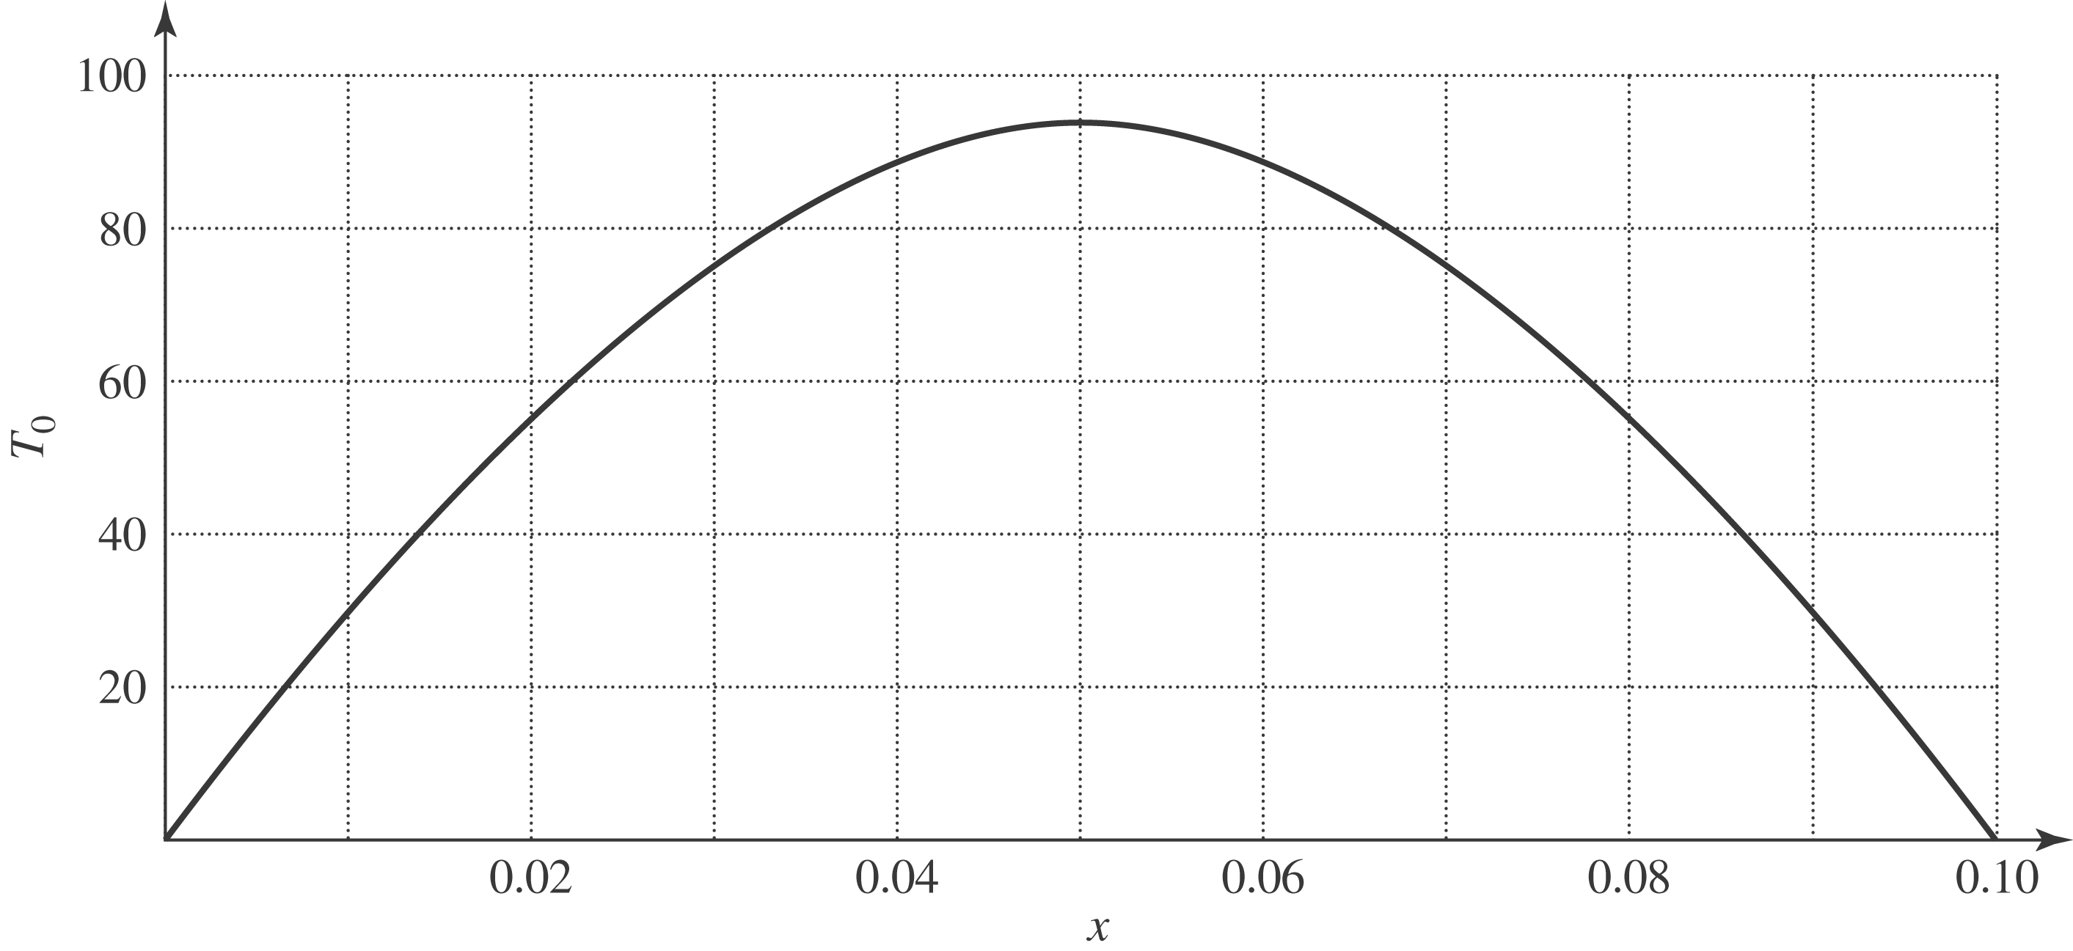

b) After a very long time, no heat will flow, and the entire rod will be at a uniform temperature which must be that of the ends, 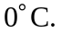
c)
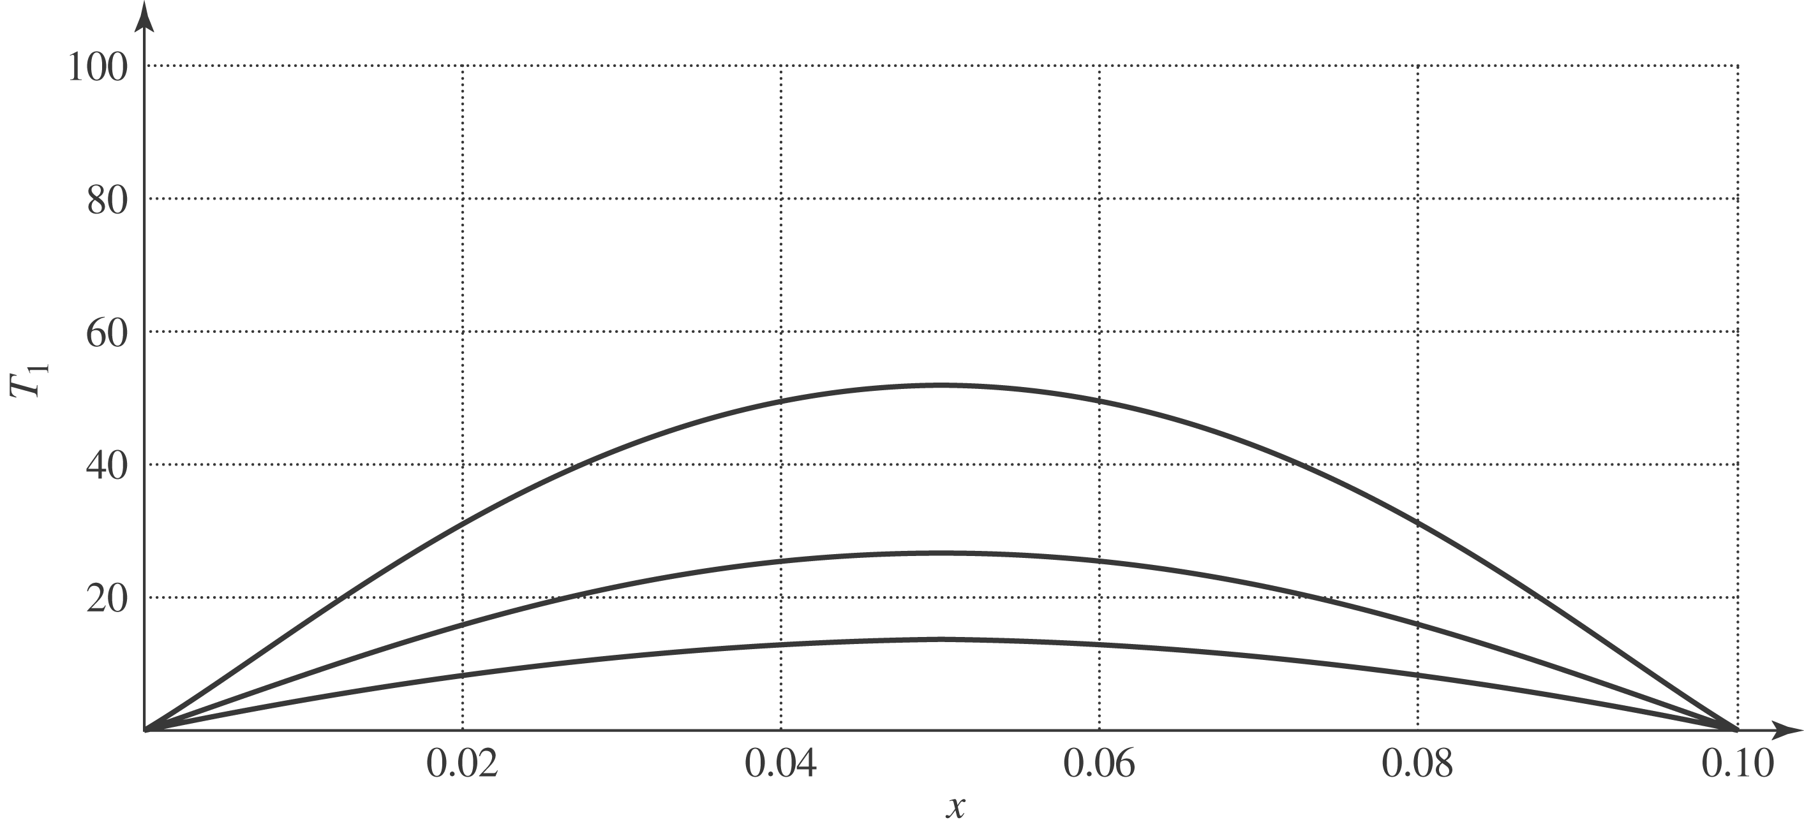

d) 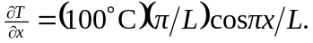 At the ends, 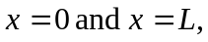 the cosine is 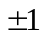 and the temperature gradient is e) Taking the phrase “into the rod” to mean an absolute value, the heat current will be 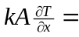
f) Either by evaluating 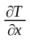 at the center of the rod, where 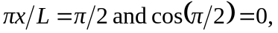 or by checking the figure in part (a), the temperature gradient is zero, and no heat flows through the center; this is consistent with the symmetry of the situation. There will not be any heat current at the center of the rod at any later time. g) See Problem 17.114;
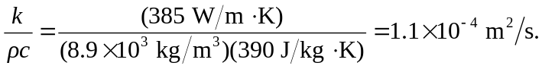
h) Although there is no net heat current, the temperature of the center of the rod is decreasing; by considering the heat current at points just to either side of the center, where there is a non-zero temperature gradient, there must be a net flow of heat out of the region around the center. Specifically,
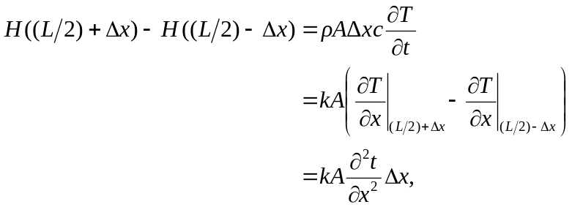

from which the Heat Equation,
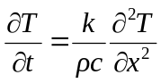
is obtained. At the center of the rod, 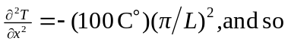
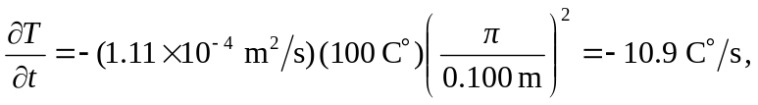
or 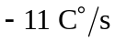to two figures. 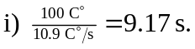 j) Decrease (that is, become less negative), since as T decreases, 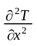decreases; this is consistent with the graphs, which correspond to equal time intervals. k) At the point halfway between the end and the center, at any given time 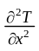is a factor of sin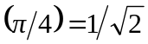 less than at the center, and so the initial rate of change of temperature is 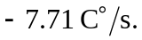A plot of temperature as a function of both position and time for 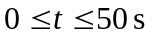is shown below.

